Joshua White
Monetally User Manual

Sec1: What is Monetally?
- Monetally is a financial aid application
- Monetally allows you to
  - See a broader view of your income and expenses
  - Distribute your income to savings
  - Get notified of upcoming expenses
  - And more!

Sec2: Getting Started With Monetally
- As of writing, Monetally is available online through GitHub Pages via mugiwara-joshuawhite.github.io/
- Upon entering the app, you will be prompted to login or sign up. If you have previously used Monetally, you may be able to enter your account information, or if you have an account file, you can upload that. otherwise, you would need to sign up.
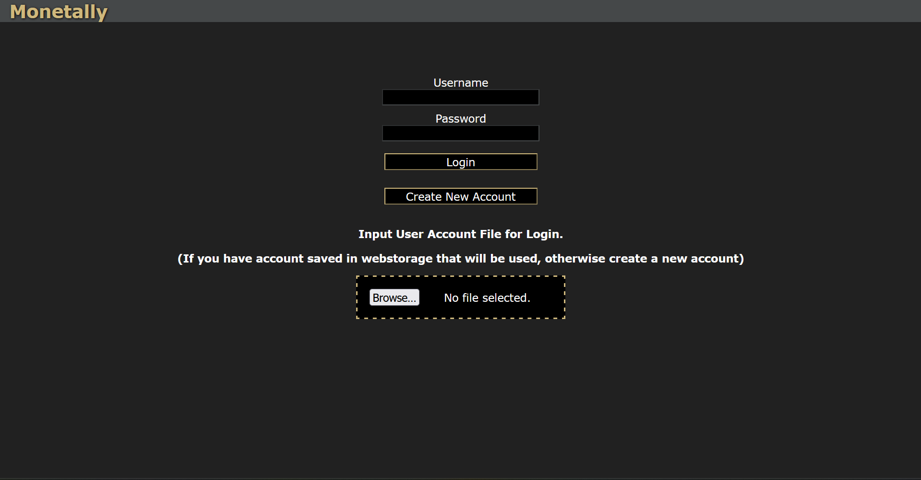

- When you sign up, you will be directed to the setup page, here, you can add two things:
  - An income stream, like a salary or check
  - An expense, like a bill or subscription
  - A distribution, if you want to, for example, dedicate 25% of income into savings.

Sec3: Your Data
For security, all of your data is stored locally. This means, however, that it’s possible to lose that data if your cookies were to be reset. This is why in the account tab, you are able to download a copy of your data for preservation purposes.

Sec4: Navigating the App
There are 5 tabs other than account among the site.
- On the home page, you can see your income and expenses. Click on the name of one of these to see more information.
You can also hide all upcoming or past transactions by clicking on “Upcoming/Past” respectively.


- On the income and expenses pages, you can add a transaction, modify a currently existing transaction, or delete a transaction. The distributions page allows the same thing for your distributions.
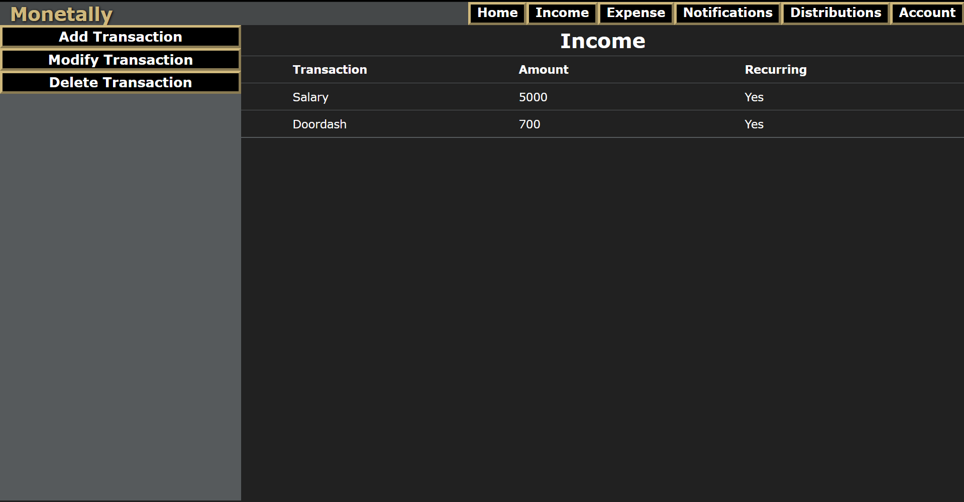

- On the notifications page, you can set a time for a notification to be sent. There are automatic notifications for upcoming expenses, but if you wish, you can customize or add new notifications.
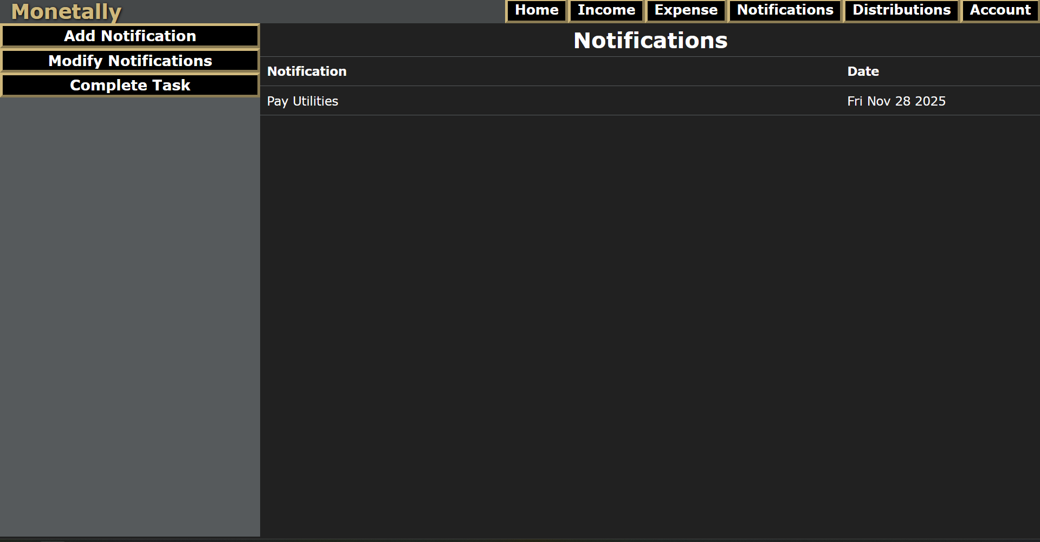

Sec4: Terms of Use
- Monetally falls under the Zlib license.
  - Under the Zlib license, the source code of Monetally is available to be modified and redistributed for commercial or non-commercial use.
  - Data is all stored locally, so open source code does not compromise any user data.
- Because Monetally is under the Zlib license, if there are any features that a user would like to have, they are allowed to modify the source code and create their own version that includes this feature.
- Under the Zlib license, we are not responsible for damages caused by any modified variants, however, we ask that you do NOT use Monetally for malicious purposes.

